Hand Gesture Controlled Car using Bluetooth Modules and Accelerometer Sensor

Ashish Kumar DuttaStudent, Dept. of EEE  
Thiagarajar College of Engineering  
Madurai   
ashish@student.tce.edu

K.G.Nitish Student, Dept. of EEE  
Thiagarajar College of Engineering  
Madurai  
nitishkg@student.tce.edu

J.Simon Gnanesh Paul Student, Dept. of EEE  
Thiagarajar College of Engineering  
Madurai   
simon@student.tce.edu

J.S.Shyam Sundar Student, Dept. of EEE  
Thiagarajar College of Engineering  
Madurai  
shyamsundarjs@student.tce.edu

S.Siddharth   
Student, Dept. of EEE  
Thiagarajar College of Engineering  
Madurai   
siddharths@student.tce.edu

P.S.ManoharanProfessor, Dept. of EEE Thiagarajar College of Engineering  
Madurai, India  
psmeee@tce.edu

*Abstract*—This research work demonstrates the usefulness of an accelerometer sensor and how it can be used to move an object using hand gestures. The device uses two Arduino UNO models, one as the transmitter and other as the receiver. The functioning of the device is based on the serial data transmitted and received through the Bluetooth modules. The data to be transmitted and received is produced by the accelerometer sensor. Based on the data received, the motors run to produce the desired movements. The device can communicate within a range of ten meters. Such a device can be used as a gesture-controlled wheelchair for handicapped people. The code for functioning is uploaded to the Arduino UNO by Arduino IDE software. The major challenge that was faced during the preparation of the model was the connection of the Bluetooth modules. Each module sends and receives data at different baud rates. If the baud rates were not same, communication will not be established. One module serially transmits the data and another module serially receives it. Different prototypes are already available with slight variations. Instead of Bluetooth modules, other modules are available to establish wireless communication. Examples are: nRF modules, RF pair, Lora WAN. As Arduino UNO is larger and consumes more space, small boards such as Arduino Nano or Arduino Lilypad has also been implemented in the available models.

Keywords— Accelerometer, Car, Bluetooth Module, Motor Driver, Arduino UNO.

# Introduction

Until the introduction of wireless communication, moving an object without using any physical push or pull seemed impossible. Today, please can access drones, run cars, operate robots by using wireless technologies. The communication protocols play a major role in it, so does the electronics. When the user toggles a button or moves a joystick, the data will get converted to digital format via a microcontroller [1]. Further, the digital data will get passed to the transmitter [4]. The transmitted data will also be received by the transmitter of another device [1]. Thus, a connection is established. This idea is implemented in our model. People having locomotor disability can be benefitted from this. They can make the device move in any desired direction using only hand gestures. If they are away from the device, they can call it using their hand. The device consists of two sub devices, a transmitter circuit to be worn in hand and a receiver circuit implemented to the device. The device has 4 motors connected to 4 wheels for smooth movement. They are powered by a motor driver [7]. The setup is powered by rechargeable batteries. The prototype uses Li ion batteries which takes about 45 minutes for charging completely. The prototype is lightweight and portable. The MCU present in this work is the Atmega328P. There are two MCUs, one for the transmitter and another for the receiver. The various other components are interfaced with the MCU through the pins present on the Arduino board. The idea of wireless controlled car is quite primitive in a sense, but the concept of hand gesture is new and creative. The accelerometer detects the change in x, y and z axis and provides the data to the microcontroller. On the basis of logic decisions, the programmer can then program a microcontroller to operate any device connected to it [6]. An important matter here is the security of the device. The device shouldn’t be vulnerable to an outsider who may get access to the device. To tackle this, the Bluetooth module provides a special feature called ‘BIND’ through ‘AT’ library. This ensures that the transmitter [5] is connected to only the receiver [2]. The device is developed as a prototype model, but all the features can be observed. This prototype can be scaled as a reliable product.

In the following sections of the paper, the technical specifications and logical design is elaborated. Section II describes the technical specifications of the device. Section III describes the implementation of the design. In section IV, the results and discussions are shown. The conclusion and future scope are discussed in the section V.

# TECHNICAL SPECIFICATION

## ADXL 335 Accelerometer Sensor

ADXL335 is a three-axis accelerometer. It is a small, thin, and low power IC. It comes with threeAccelerometer axes with signal output. The working of the chip is based on the change of capacitance. When there occurs a movement in any axis, the corresponding capacitance changes according to the Eq. (1).

C= εA/d (1)

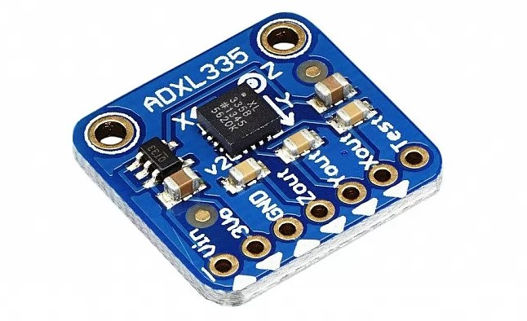

Fig. 1 ADXL 335 Accelerometer Sensor

When this capacitance is changed, the corresponding data is sent to the microcontroller.

## HC05 Bluetooth Module

HC05The module can be used as a transmitter or a receiver. The user can program this module using programmable devices like Arduino UNO. The module effectively communicates with other modules in a range of ten meters. The module can be programmed as a master or a slave device. This module can be interfaced with MCU, ARM or DSP systems. The operating voltage is 3.3V to 6V and the working current for the module is 30 mA. The module operates on Bluetooth v2.0 Protocol standards.

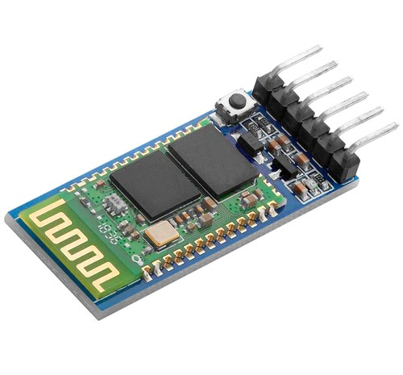

Fig. 2 HC05 Bluetooth Module

The default bit rate is 9600 bits/s however the user can be change it using AT mode. The module also comes with a LED indicator light, which displays the various states of the device. It has 6 pins however the important ones are VCC, GND, TXD and RXD. The module sends or receives data through TTL logic. The commands like: ADDR, ROLE and BIND were used to accomplish one on one connection between two modules.

## L298N Motor Driver

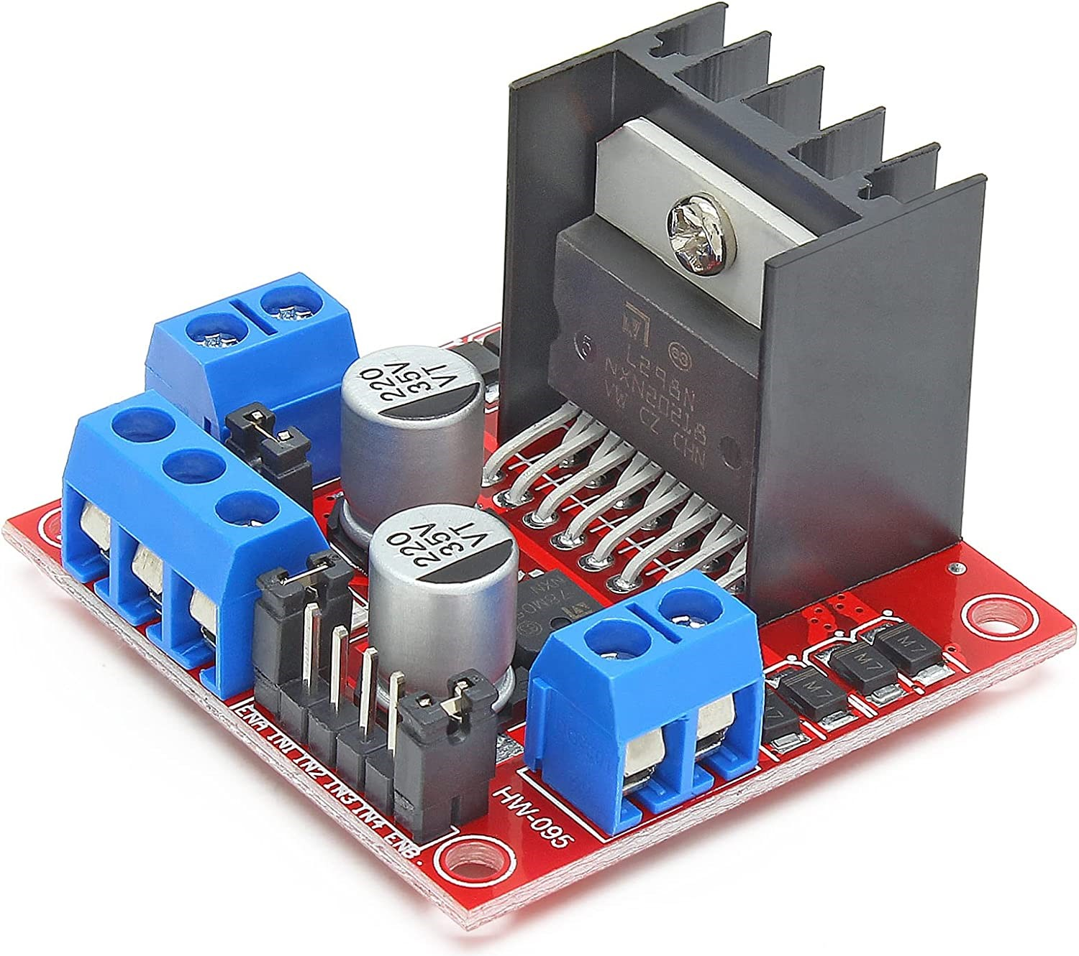

Fig. 3 L298N Motor Driver

L298NMotor Driver can control the speed and direction of DC drives. The operating voltage is in between 5 Volts and 35 Volts, and the peak current is 2Amps. The modules have several features. The module is implemented to control the wheels through the motors in the device. The control signals are given by the microcontroller of Arduino UNO. By providing the supply to the different motors, we can control the movement of the device. L298N driver works on logic levels. A logic 1 means that the supply must be given to the port. On the contrary, a logic 0 means that the supply must be cut off to that port. The voltage regulator in the module plays an important role. It ensures that the voltage between the ends of the two motors is five volts and does not drop which helps in the smooth operation of the motors.

## *Battery Operated DC Motor*

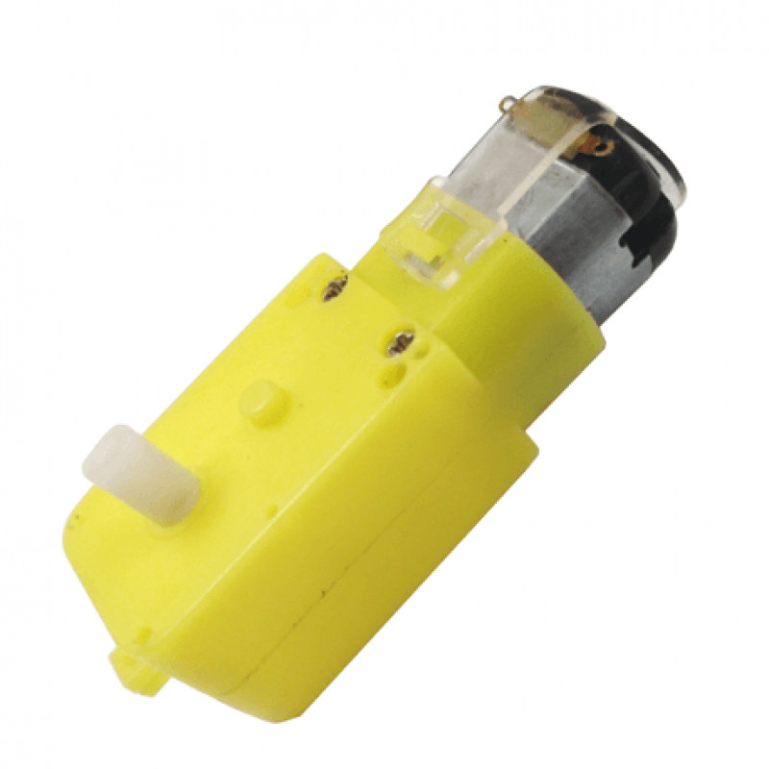

Fig. 4 Battery Operated DC Motor

This is a small battery-operated DC with an operating voltage of 3V to 12V. The motor offers a good torque and decent rpm even at lower operating voltages. This feature is the biggest advantage of these motors. On the outer frame, a small shaft is provided to which wheels are connected. The idea is simple, as the motor rotates, the wheel also rotates resulting in the movement of the device. The motor has mounting holes on the body for proper placement on the structure. This motor can be used with a wheel up to 69mm in Diameter. It proves to be the best alternative to a metal gear DC motor. The drawback of heavy weight of the metal gear DC motor is overcome by this motor. Also, because of low inertia, the motor is capable to turn in different direction immediately. It also has the capability to absorb vibration and shock because of its elastic compliance. It has the ability to operate with minimum lubrication, due to its inherent lubricity. It also has relatively low coefficient of friction. Hence, this motor is ideal for application is gesture controlled mobile device.

# DESIGN IMPLEMENTATION

Figure 5 describes the functioning of the transmitted and the receiver.

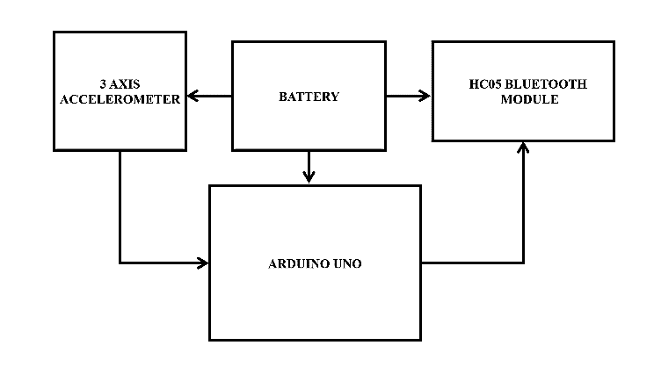

Fig. 5 Transmitter block diagram

The transmitter block diagram is shown in Fig.5. The power is given to all the components by a 9V battery. Any movement in the transmitter circuit is detected by the accelerometer [2] and the corresponding data is sent to Bluetooth through Arduino UNO. Arduino UNO is used because of its reliability and usability. It provides various analog and digital pins for use. Moreover, Arduino UNO can be easily programmed by Arduino IDE software. Hence the transmitter circuit picks up a signal and transmits it.

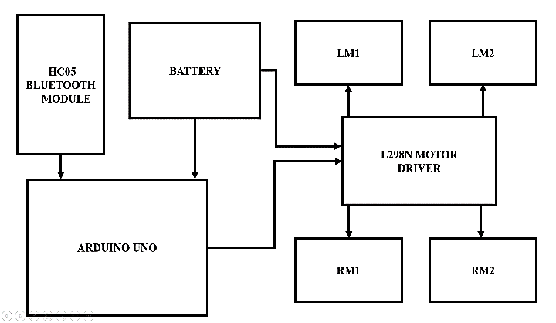

Fig. 6 Receiver block diagram

The functioning of the receiver module is described in Fig.6. The module is powered by a series combination of four rechargeable Li ion batteries, each 3.7V. So, the total voltage applied is ideally 14.8V. The wheels are connected to the base of the proposed module which are revolved through the motors. The Bluetooth module receives the data from the transmitter. It is then sent to the Arduino UNO. Based on the data received, it sends signals to the L298N motor driver which further runs the motors. Hence the device is gesture controlled [3].

## Circuit Diagrams

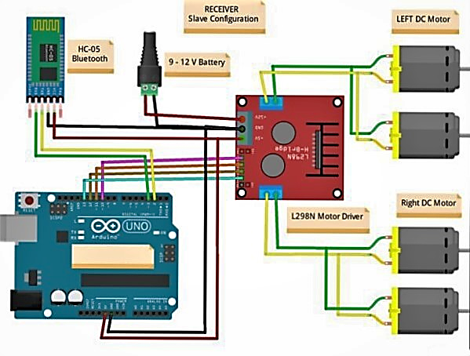

Fig. 7 Receiver circuit

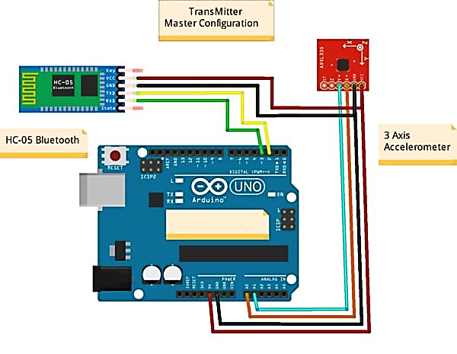

Fig. 8 Transmitter Circuit

## Working Principle

Inferring from Fig. 8, we can observe that the accelerometer sensor provides input to the Arduino UNO. The accelerometer is connected to the Arduino as given in Table I.

TABLE I. CONNECTION PINS OF ACCELEROMETER

| Arduino UNO | Accelerometer |
| --- | --- |
| +5V | VCC |
| GND | GND |
| A0 pin | X |
| A1 pin | Y |

The analog inputs through the accelerometer are given to A0 and A1 pins. The accelerometer is used for measuring the linear acceleration. This structure is suspended by polysilicon springs. It allows the structure to deflect when accelerated along the X, Y, and/or Z axes. As a result of deflection, the capacitance between fixed plates and plates attached to the suspended structure change. This change in capacitance is proportional to the acceleration along that axis. The sensor processes this change in capacitance and converts it into an analog output voltage. This voltage is used to detect the motion of the transmitter. According to the analog through A0 and A1, the microcontroller decides the motion of the transmitter module. Correspondingly, a character is generated. The character ‘F’ denotes the FORWARD motion of car; character ‘B’ denotes the BACKWARD motion, character ‘R’ denotes the RIGHT direction and ‘L’ denotes LEFT. These characters are then serially transmitted through the Bluetooth module. The detail of connection between Arduino and HC-05 Bluetooth is given in Table II [8].

TABLE II. CONNECTION BETWEEN ARDUINO AND HC-05 BLUETOOTH

| Arduino UNO | HC-05 Bluetooth Module |
| --- | --- |
| +5V | VCC |
| D3 pin | RX pin |
| D2 pin | TX pin |
| GND | GND |

The character generated by the microcontroller is sent to Bluetooth via *TX*. Upon successful receival of the data, the other Bluetooth module sends an acknowledgement is received through *RX* which ensures that the data has been transmitted successfully by the microcontroller. The next phase of the device is the receiver module [9]. Inferring from Fig. 7, we can observe that the Bluetooth module provides the received data to the microcontroller.

Based on the received character, the motion logic is decided [15]. The motion is controlled by the motor driver. The connection between the motor driver and Arduino UNO is as given in Table III. The transmitter module is connected to the receiver module through HC05 Bluetooth modules. The transmitter circuit’s Bluetooth module is configured as ‘master’ whereas the receiver circuit’s Bluetooth module is configured as ‘slave’. The master module is configured to pair with only one slave module. The configuration of the Bluetooth module is done using AT mode. The commands used are AT+UART, AT+ROLE, AT+ADDR, AT+BIND. Hence, the connection is secure and is effective.

TABLE III. MOTOR DRIVER CONNECTIONS

| Arduino UNO | Motor Driver |
| --- | --- |
| +5V | +5V |
| D10 pin | IN1 |
| D11 pin | IN2 |
| D12 pin | IN3 |
| D13 pin | IN4 |

The GND of the motor driver is connected to the GND pin of the Arduino UNO. The motors are connected to the motor driver as follows: The left side motors 1 and 2 are connected to the common terminals 1 and 2 of the driver. Similarly, the right-side motors 1 and 2 are connected to the common terminals 3 and 4 of the driver [10]. The microcontroller is programmed to enable or disable motors according to the character received by it. Hence, it can provide accurate real time movements with synchronization to the transmitter [14].

# RESULTS AND DISCUSSION

The prototype was developed to accomplish the objective of gesture control. The final prototype is as per the expectations. With a battery of 14.8V, the model can run for about 45 minutes if used continuously. The response is fast and accurate. However, the effectiveness reduces as the distance between the transmitter and the receiver decreases. After 12 meters, the response is vague. The following images were taken after the successful completion of the device.

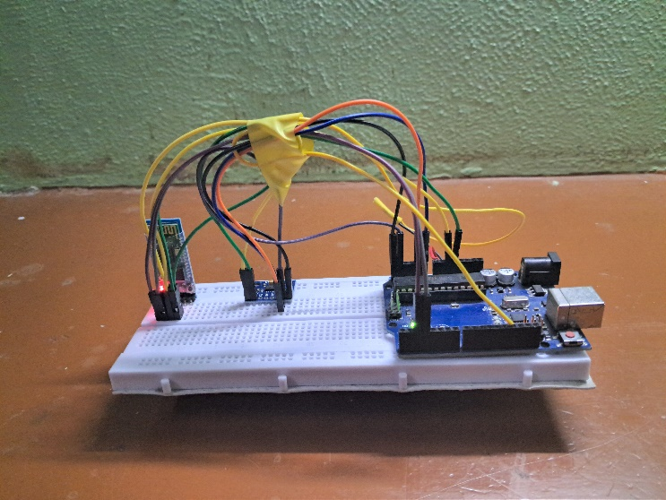

Bluetooth Module

Accelerometer

**Arduino**

Fig. 9. Transmitter module

Figure 9 shows the transmitter module from various views. It can be worn on hand using a Velcro. Moving this module in various directions will send different signals between the Bluetooth modules [11]. The various components in it are supplied by a 9V battery connected to it. The response of this module is fast and accurate. The circuit is simple, and a compact model can be built in future.

Fig. 10 - Fig. 12 show the front view, side view and top view respectively of the receiver module. The initial tests showed negative results. Initially, two Li ion batteries, 3.7V each were used. It was found that the battery couldn’t supply enough power to four motors for a long period. Then, four batteries were connected in series and then used as the source provided the optimal result. There are models already available for the proposed title. However, the prototype is expensive and not scalable. Using, nRF modules increases the range of connectivity but it increases the cost. The prototype model is small is size, but it can be scaled higher while the concept remains the same.

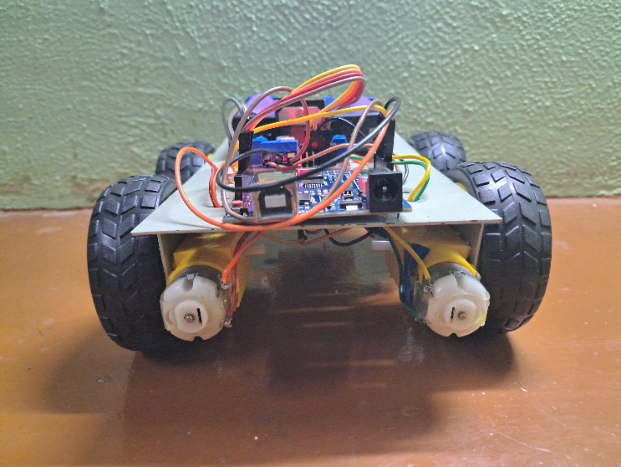

Fig. 10. Front view of the Receiver module

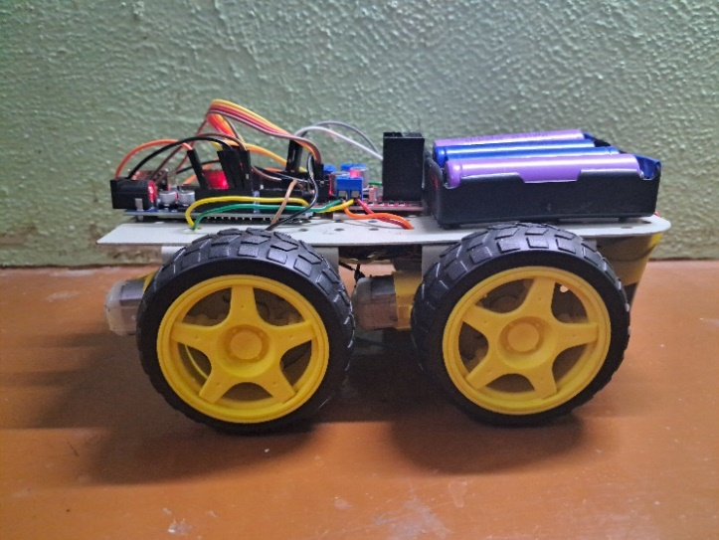

Fig. 11. Side view of the Receiver module

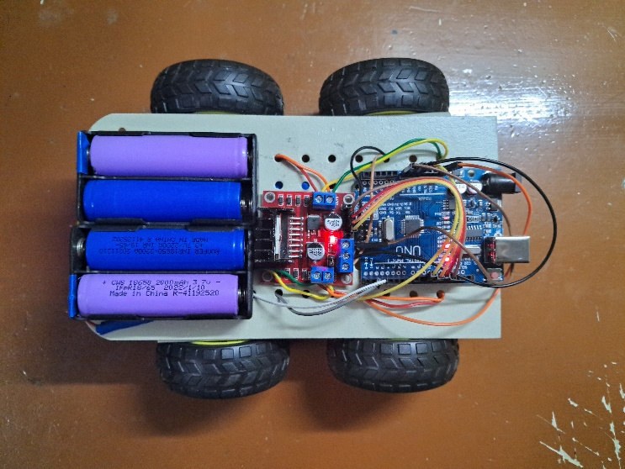

Bluetooth Module

**Motor Driver**

**Arduino**

**Battery**

Fig. 12. Top view of the Receiver module

# CONCLUSION AND FUTURE SCOPE

As several electronic devices were used to build this model, practically various losses occur in all the components. The transmitter circuit can work for about six hours continuously on battery. The receiver circuit has motors with high initial torque. The power consumed is huge, each time they are started. Hence it can operate for about forty-five minutes continuously on battery. The operation is almost noiseless. Considering the prototype, the output parameters came out decent. Scaling this prototype into larger projects can help people in several fields. In military warfare, such a device can be developed as an unmanned compact vehicle to detect land mines on the field. In municipal corporations, this can be operated in the sewers to check and clear blockages when equipped with proper components. It can also be modelled as an electronic wheelchair which can be used by handicapped people for easily controlling the wheelchair. There can be numerous possibilities of the evolution of this model to perform various roles in various fields. In this era of automation, developing and enhancing such prototypes will be helpful to humankind.

# Acknowledgment

We express our gratitude to our institution, Thiagarajar College of Engineering, Madurai for extensive support.

##### References

1. A. Asokan, A.J.Pothen, R.K Vijayaraj, “ARMatron - A wearable gesture recognition glove: For control of robotic devices in disaster management and human rehabilitation”, International Conference on Robotics and Automation for Humanitarian Applications, Dec 2016.
2. Kim, Kyung & Kwak, Keun-Chang & Ch, Su. (2006). Gesture analysis for human-robot interaction. Proc. of the Int. Congress on Anti Cancer Treatment, Phoenix, Arizona. 4 pp.1827.
3. Kianoush Haratiannejadi and Rastko R. Selmic, “Smart Glove and Hand Gesture-Based Control Interface for Multi-Rotor Aerial Vehicles in a Multi-Subject Environment”, IEEE Access, vol. 8, pp.227667-227677, Dec 2020.
4. Aditya P, Akhil DP, Arunav B, Akshaykumar G, Pankaj, “Hand Gestures Controlled Robotic Arm”, Journal of International Academic Research for Multidisciplinary, vol.2, no.4, pp.234-240, 2014.
5. <https://techatronic.com/how-to-make-gesture-control-robot-using-arduino/>
6. J.Pradeep, Dr. P. Victor Paul” Design and Implementation of Gesture Control Robotic Arm for Industrial Appliances”, International Journal of Advanced Scientific Research & Development, vol.03,pp.202-209,Dec’2016.
7. Aswath S, Chinmaya Krishna Tilak, Amal Suresh and Ganesha Udupa, “Human Gesture Recognition for Real-Time Control of Humanoid Robot”, International Journal of Advances in Mechanical and Automobile Engineering (IJAMAE), Vol. 1, Issue 1, PP.96-100, (2014).
8. Gaurav Gautam, Abhijeet Ashish, Anil Kumar, Avdesh, “Wirelessly Hand Glove Operated Robot”, International Journal of Advanced Research in Electronics and Communication Engineering (IJARECE), Volume-3, Issue-11,PP.-1546-1547, November 2014.
9. Shruthi B. N, Shivraj, Sumathi S, “Hand Gesture Based Direction Control of Robocar using Arduino Microcontroller”, International Journal of Recent Technology and Engineering (IJRTE), Volume-3, Issue-3, PP. 32-35, July 2014.
10. A.P.S. Ramalakshmi, P.S. Manoharan, K. Harshath, and M. Varatharajan, “Model predictive control of 2DOF helicopter”, International Journal of Innovation and Scientific Research, Volume 24, Issue 2, June 2016, Pages 337–346.
11. M. Jain, M. Sehgal, Y. Kalra, P. Jain, N. Aggarwal, R. Singh, D. Kumar, T. K. Bera and R. Singh, “Object Detection and Gesture Control of Four-Wheel Mobile Robot,” in International Conference on Communication and Electronics Systems (ICCES), Coimbatore, 2019.
12. S. Ikegami, C.Premachandra, B. Sudhantha and S. Sumathipala, “Study on Mobile Robot Control by Hand gesture Detection,” in 3rd International Conference on Information Technology Reaseach (ICITR), Moratuwa, Sri Lanka, 208.
13. S. C. Narsingoju Adithya, “Hand Gesture Controlled Robot,” International Journal on Recent Technology and Engineering (IJRTE), vol. 8, no. 1S4, 2019.
14. Monika Jain, Aditi, Ashwani Lohiya, Mohammad Fahad Khan, and Abhishek Maurya, “Wireless Gesture Control Robot: An Analysis,” International Journal of Advanced Research in Computer and Communication Engineering, vol. 1, no. 10, pp. 855-857, December 2012.
15. K. Brahmani, K. S. Roy, and Mahaboob Ali, “Arm 7 Based Robotic Arm Control by Electronic Gesture Recognition Unit Using Mems”, International Journal of Engineering Trends and Technology, Vol. 4, no. 4, April 2013.